Khao Phansa Festival (Beginning of Buddhist Lent)

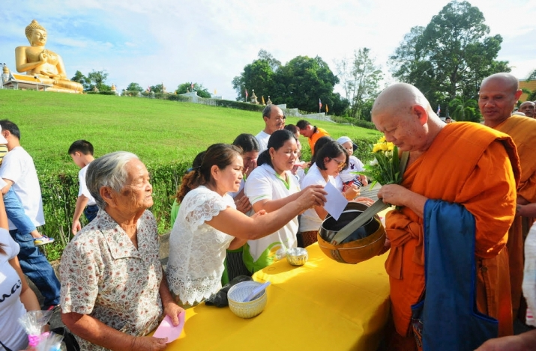

This is the beginning of the three-month long Buddhist Lent. All monks stop travelling and stay at temple for prayer and meditation. It's also time for ordination of men entering a monkhood.

The Khao Phansa is the traditional three month "rains retreat" during which Buddhist monks are expected to stay in their own temple to study the Buddha’s teaching as well as meditating. They are not allowed to travel and stay overnight out of their temples, but under certain circumstances, such as visiting a sick relative, they maybe given a leave period of up to seven days.  
During this three months retreat monks are not allow to revert to being laymen.

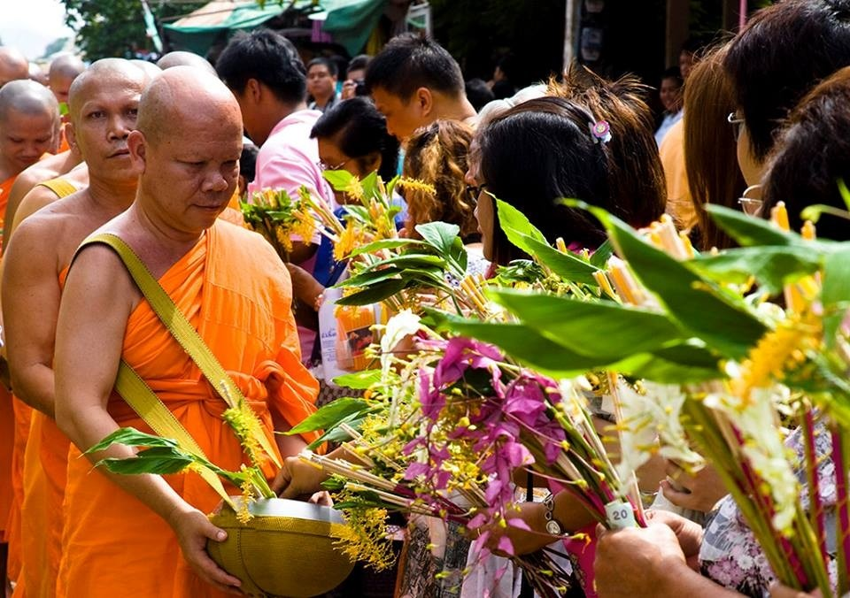

Lay Buddhists all over the country observe the day (the first day of Buddhist Lent) by gathering in the temple to pay homage to the Buddha, listen to Buddhist teaching accompanied by offerings of food, flowers, incense, candles and other items necessary for every use for the monks.

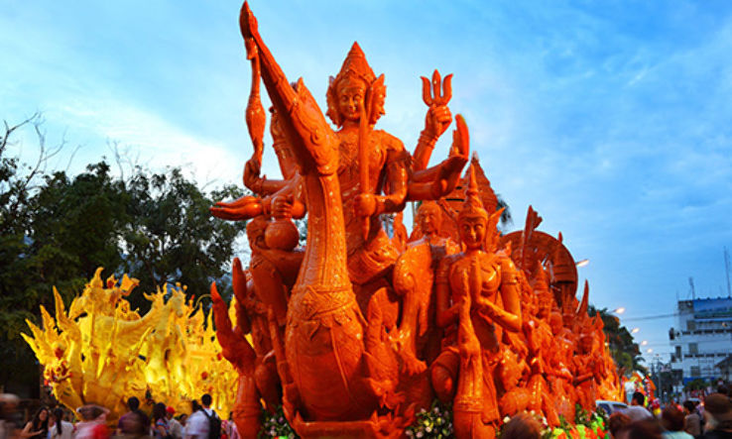

According to legend Buddha’s followers did not stop their wandering during the rainy season and people began to complain that they were trampling on the rice fields and worried they might damage seedlings or small creatures in the fields. When the Buddha heard these worries he forbade the monks to leave their temples for three months.

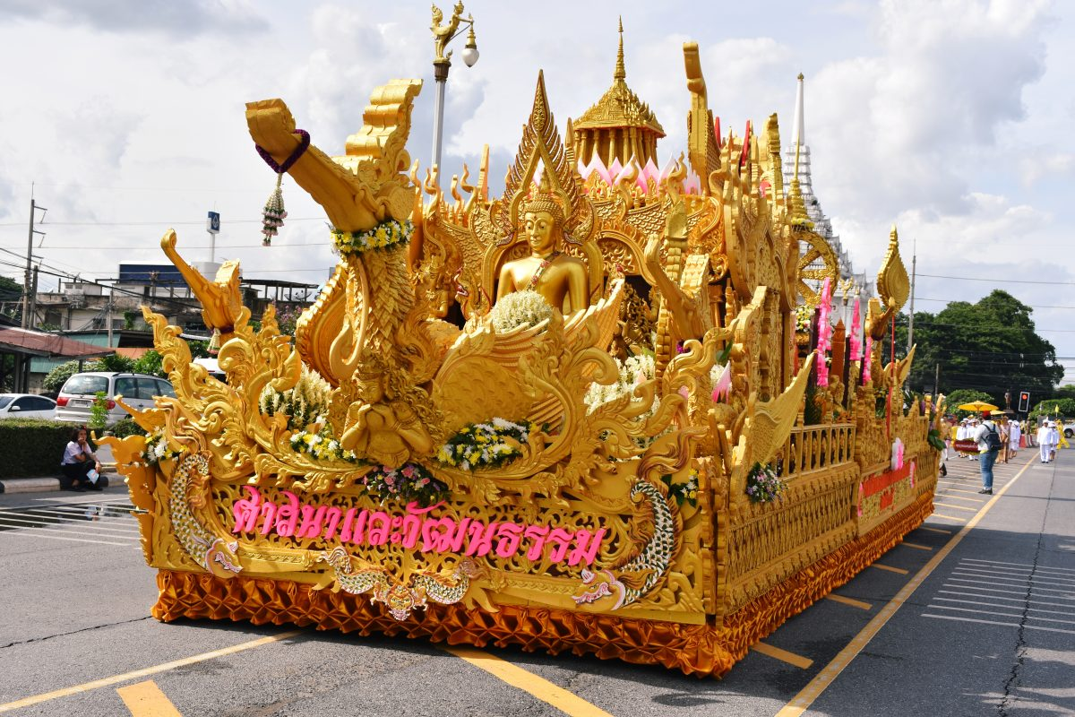

During this time devout people often abstain from alcohol. They pray for assistance and guidance to encourage merit and happiness in their lives. It encourages them to follow the five major Buddhist precepts: don’t kill animals; don’t steal or engage in corrupt acts; don’t commit adultery; don’t lie; and avoid drinking alcohol. Many take time away from work to make merit for deceased relatives. They also offer robes to the monks.

In Lao tradition lay people do not get married during this three months Buddhist lent or Khao Phansa. The Lent ends on the full moon of the eleventh month on lunar calendar which is in October (in most years).

Awk Phansa Festival (End of Buddhist Lent)

End of Buddhist Lent (Boun Awk Phansa in Lao language) is one of significant Laos festivals. The festival starts with alms giving ceremonies in early morning and in the evening there is lighting of candles in and around the temples and the lovely ceremony of Lai Hua Fai or fireboats, where small "boats" made of sections of banana tree trunks decorated with flowers, and lit candles are floated down the nearest river.

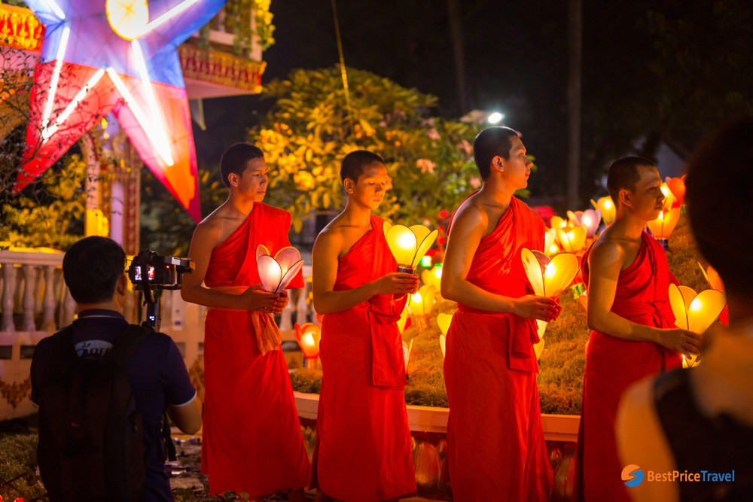

In Vientiane and the border town of Nong Khai, Thailand, this is the day that the Naga (mythical water spirit) is supposed to send fireballs into the sky from the Mekong which has become a big attraction for many people who flock to the river banks to try to sight these elusive fireballs.

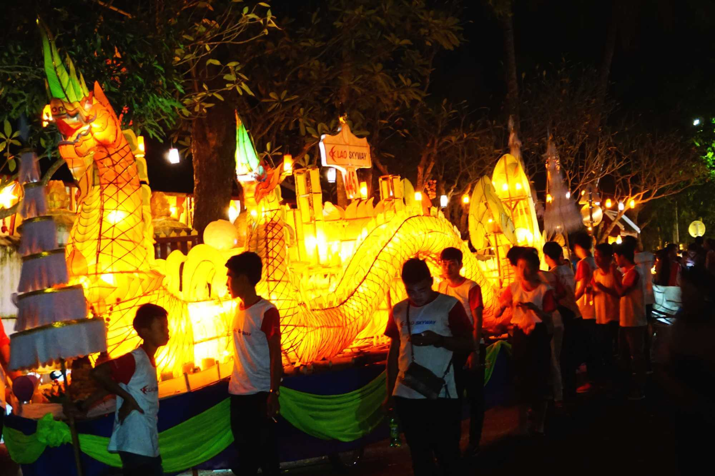

The End of Buddhist Lent festival takes place at every temple around the country though some may omit the floating of the decorative boat on the river as not all communities or villages are located near a river, but all will do the morning almsgiving procession and decorate lighted boat at the temples.

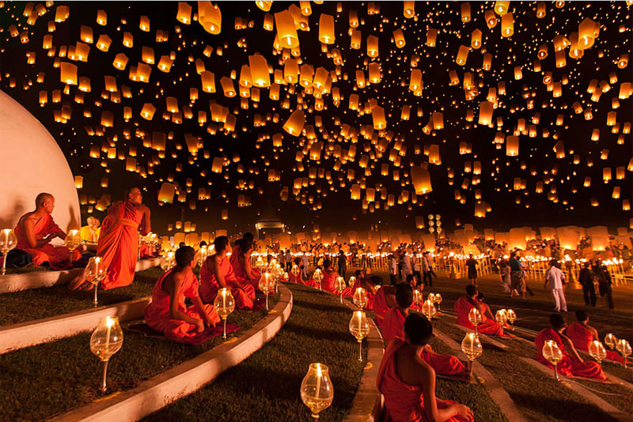

In Luang Prabang, it is also significant. On the full moon day, there is early morning alms giving at every temple followed by the That Phousi and Vat Vixoun festivals.

In the evening decorated boats will be carried from the centre of Luang Prabang to Wat Xiengthong (Xiengthong temple) where they will be taken down to the river and launched from 7pm to 11pm